# Lab 4

## Load the “it_ops*” data

1. From Machine Learning tab, select Data visualiser -> Import Data and load the “it_ops_app_logs.json” file

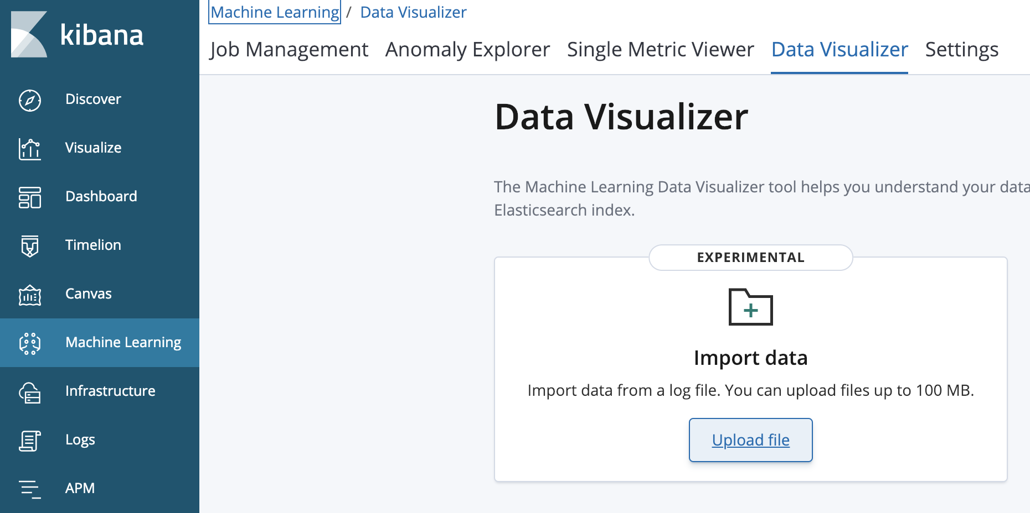

2. Cllick Import



3. Enter the index name “it_ops_app_logs”

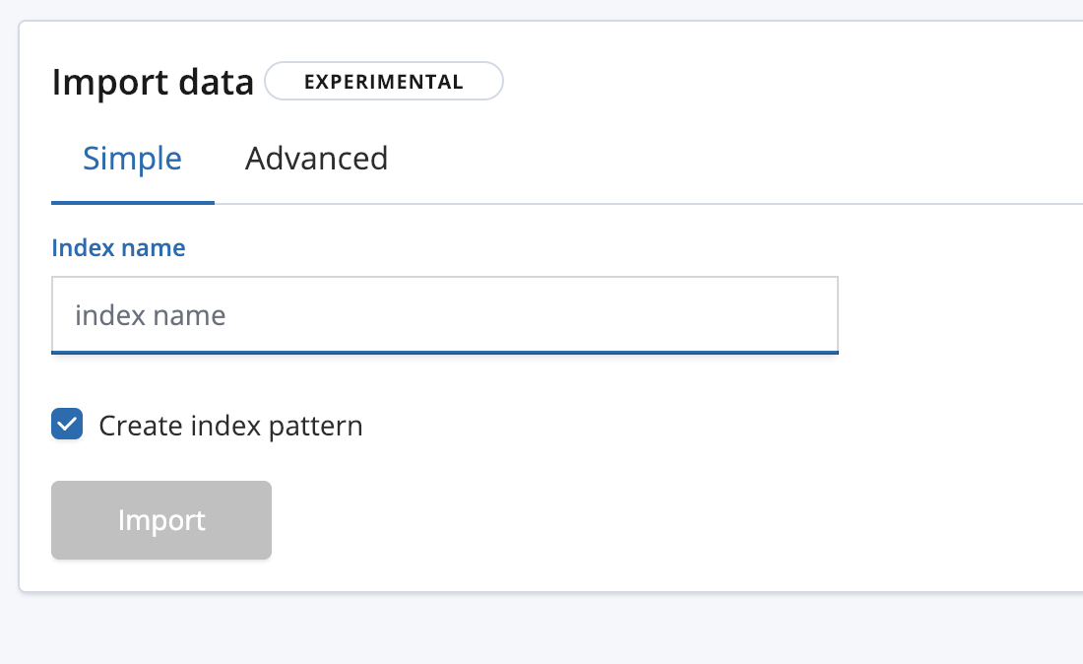

4. Wait for the Upload to finish.

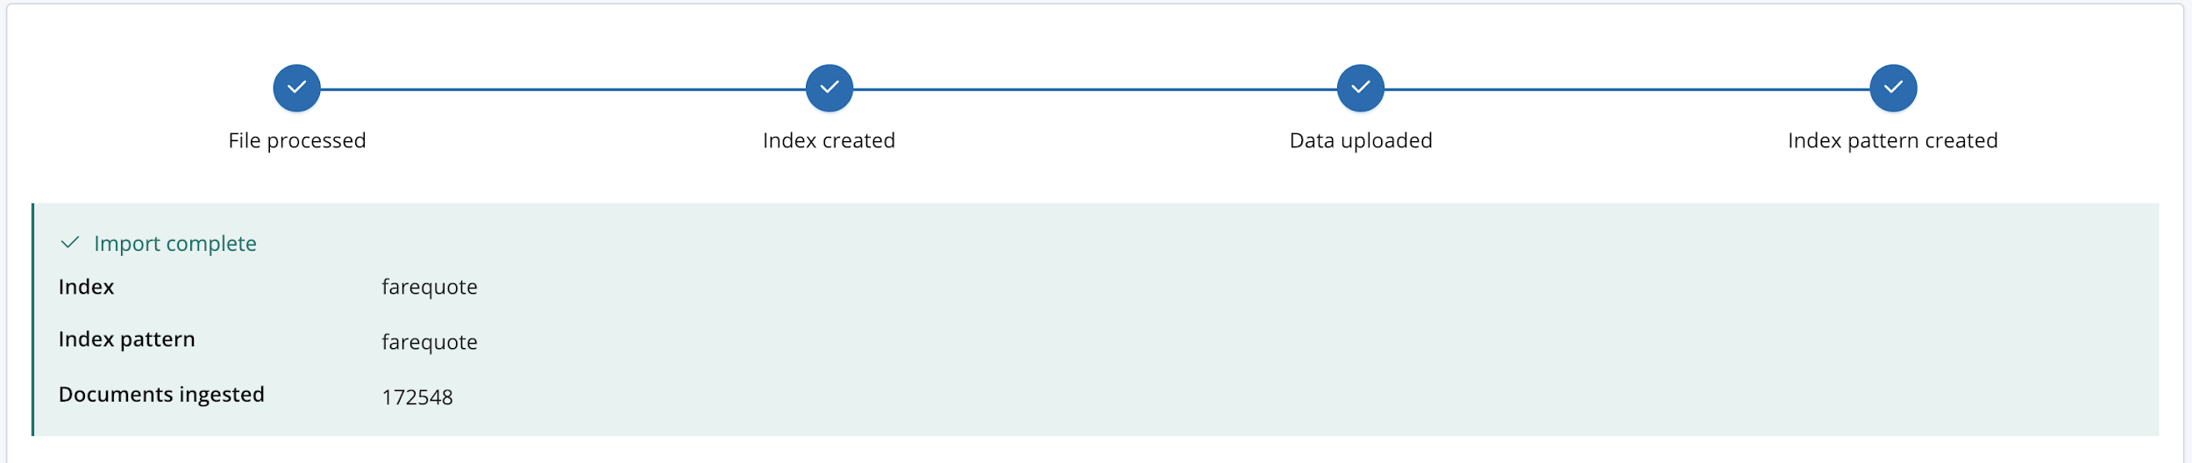

5. Repeat the above steps to create the following indices:

* It_ops_sql from it_ops_sql.json
* It_ops_network from it_ops_network.json
* It_ops_kpi from it_ops_kpi.json

## Problem

* Transaction processing app records # transactions per minute in an index called “it_ops_kpi”. Find the anomaly in it.
* Also, SQL Database and Network performance metrics were gathered for the application environment (it_ops_network and it_ops_sql). Use multi-metric jobs to see what might be going on in there.
* Lastly, there’s an index (it_ops_app_logs) that has the application’s log lines in them. See if there’s anything anomalous in there as well.  
  View all jobs correlated together in the Anomaly Explorer

# Solution

## Create and Advanced job for “it_ops_app_logs” index

For index:it_ops_app_logs

* create an advanced job
* put job in a group
* make sure you choose   
  “message” for  
  categorization_field_name
* detector is:  
  count with by_field_name of  
  “mlcategory”

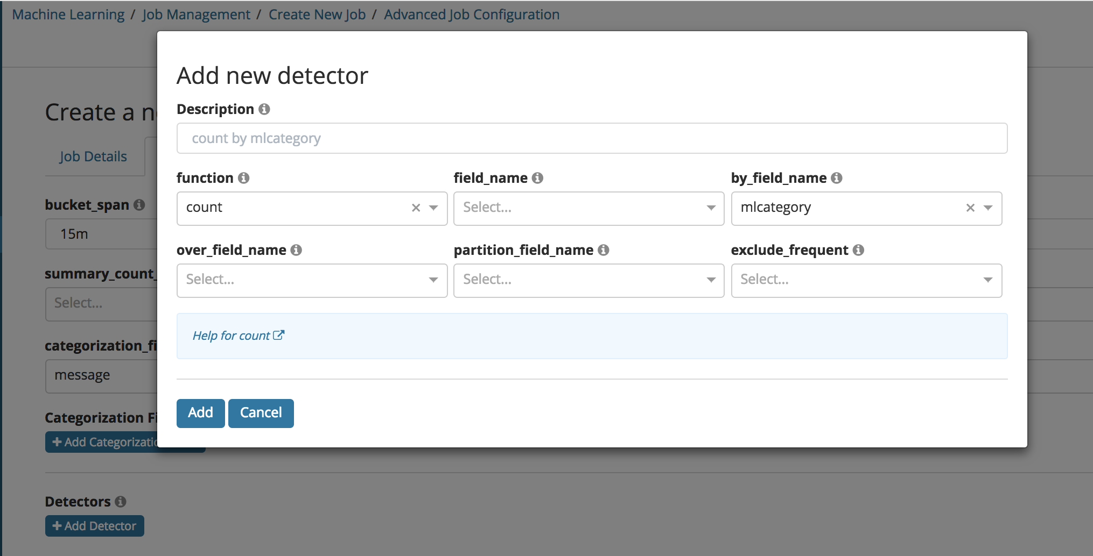

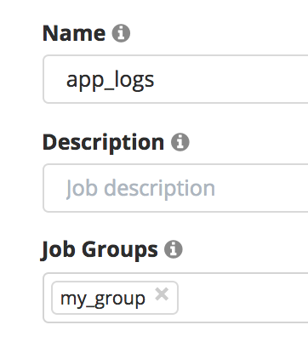

## Create Multi-Metric jobs for the following indices “it_ops_sql” and “It_ops_network”

For index:it_ops_sql* create multi-metric job. Set “mean” for all SQL metrics. Also put job in same Job Group as the app logs job.

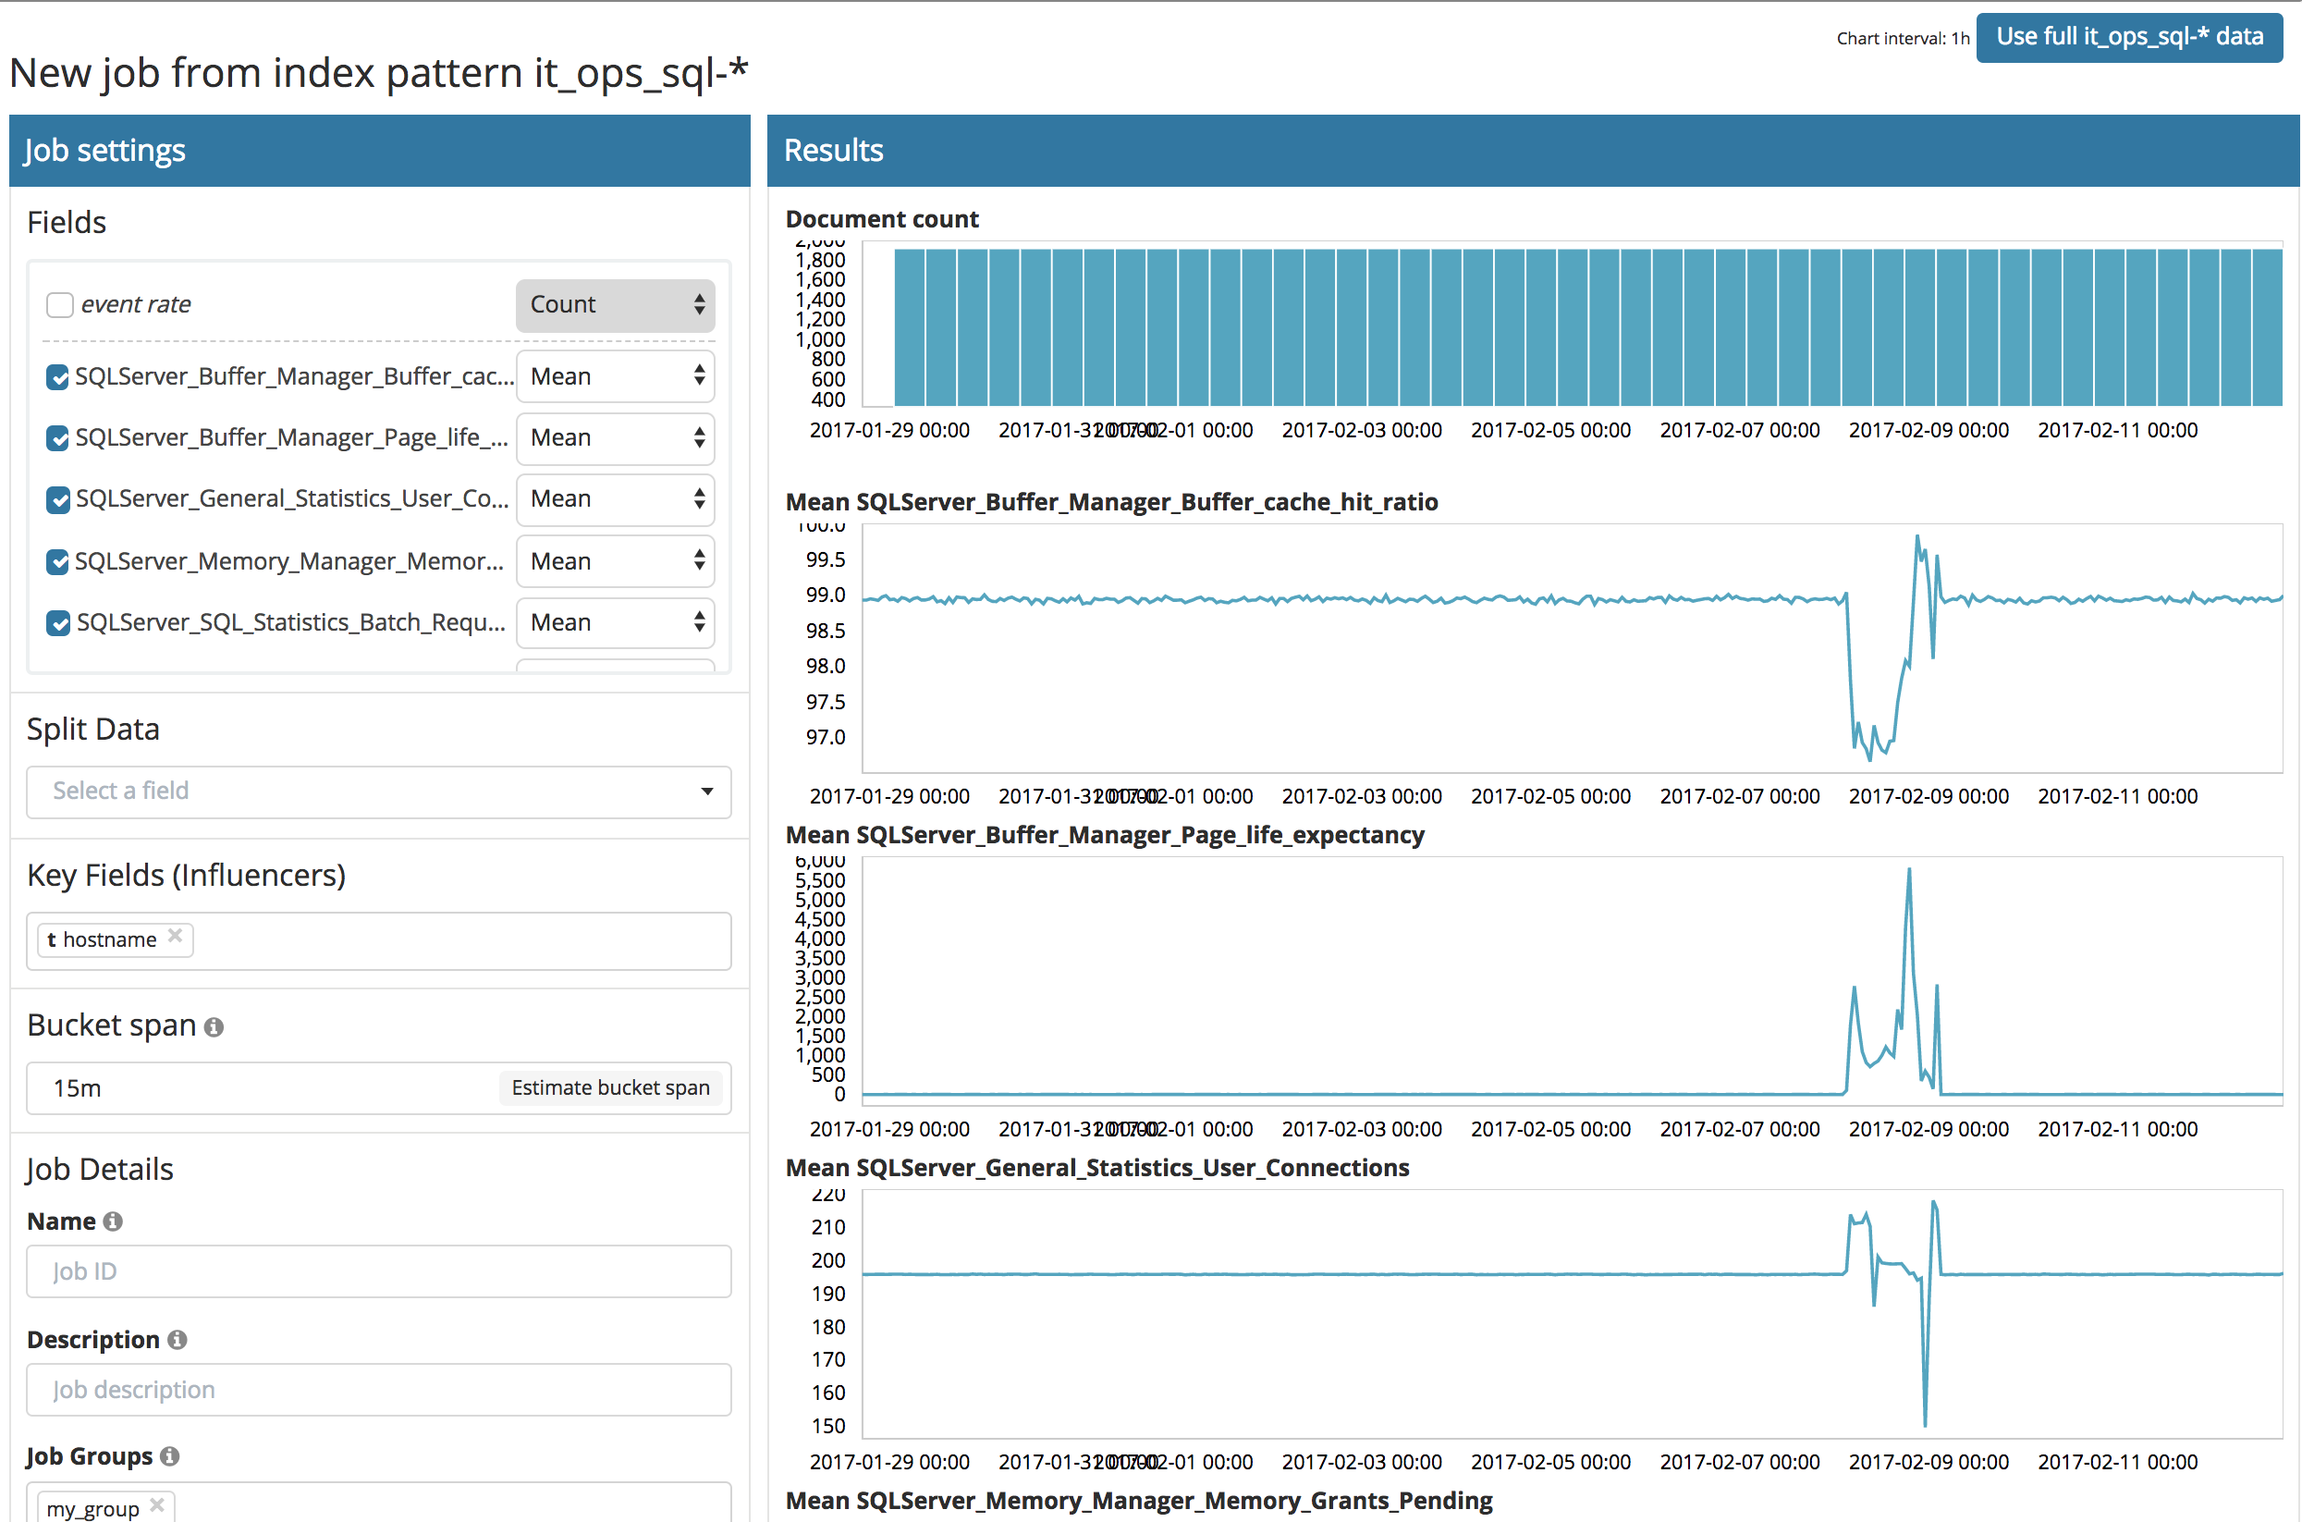

For index:it_ops_network create multi-metric job. Set “mean” for all metrics. Also put job in same Job Group as the app logs job.

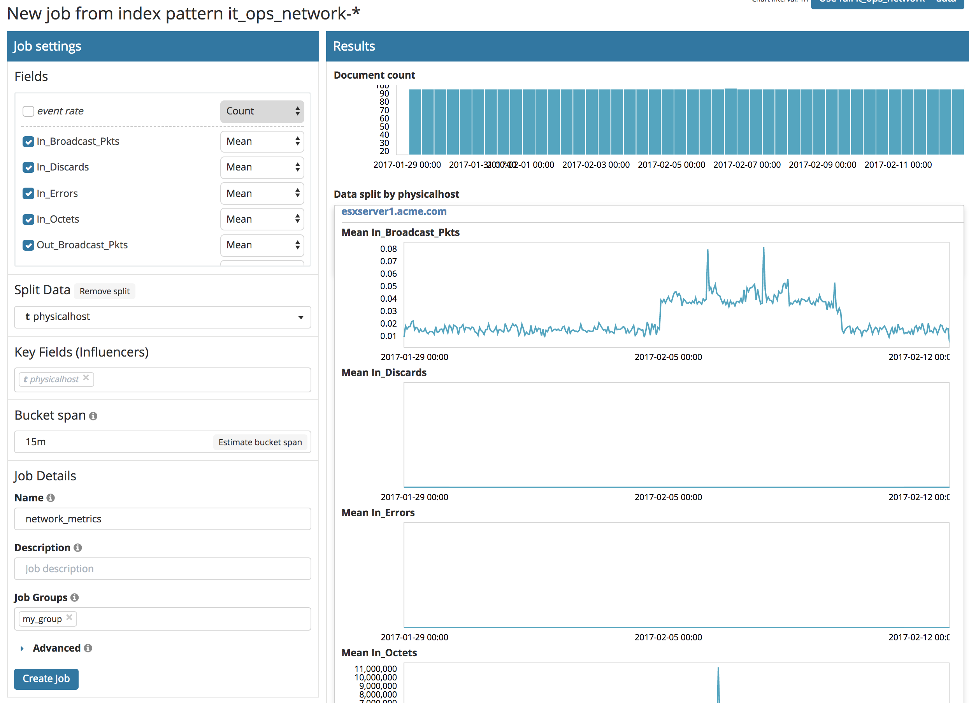

## Create a “low_sum” Single-Metric job for the following index “it_ops_kpi”

For index:it_ops_kpi create single-metric job “low_sum” for field “events_per_min”. Also put job in same Job Group as the app logs job

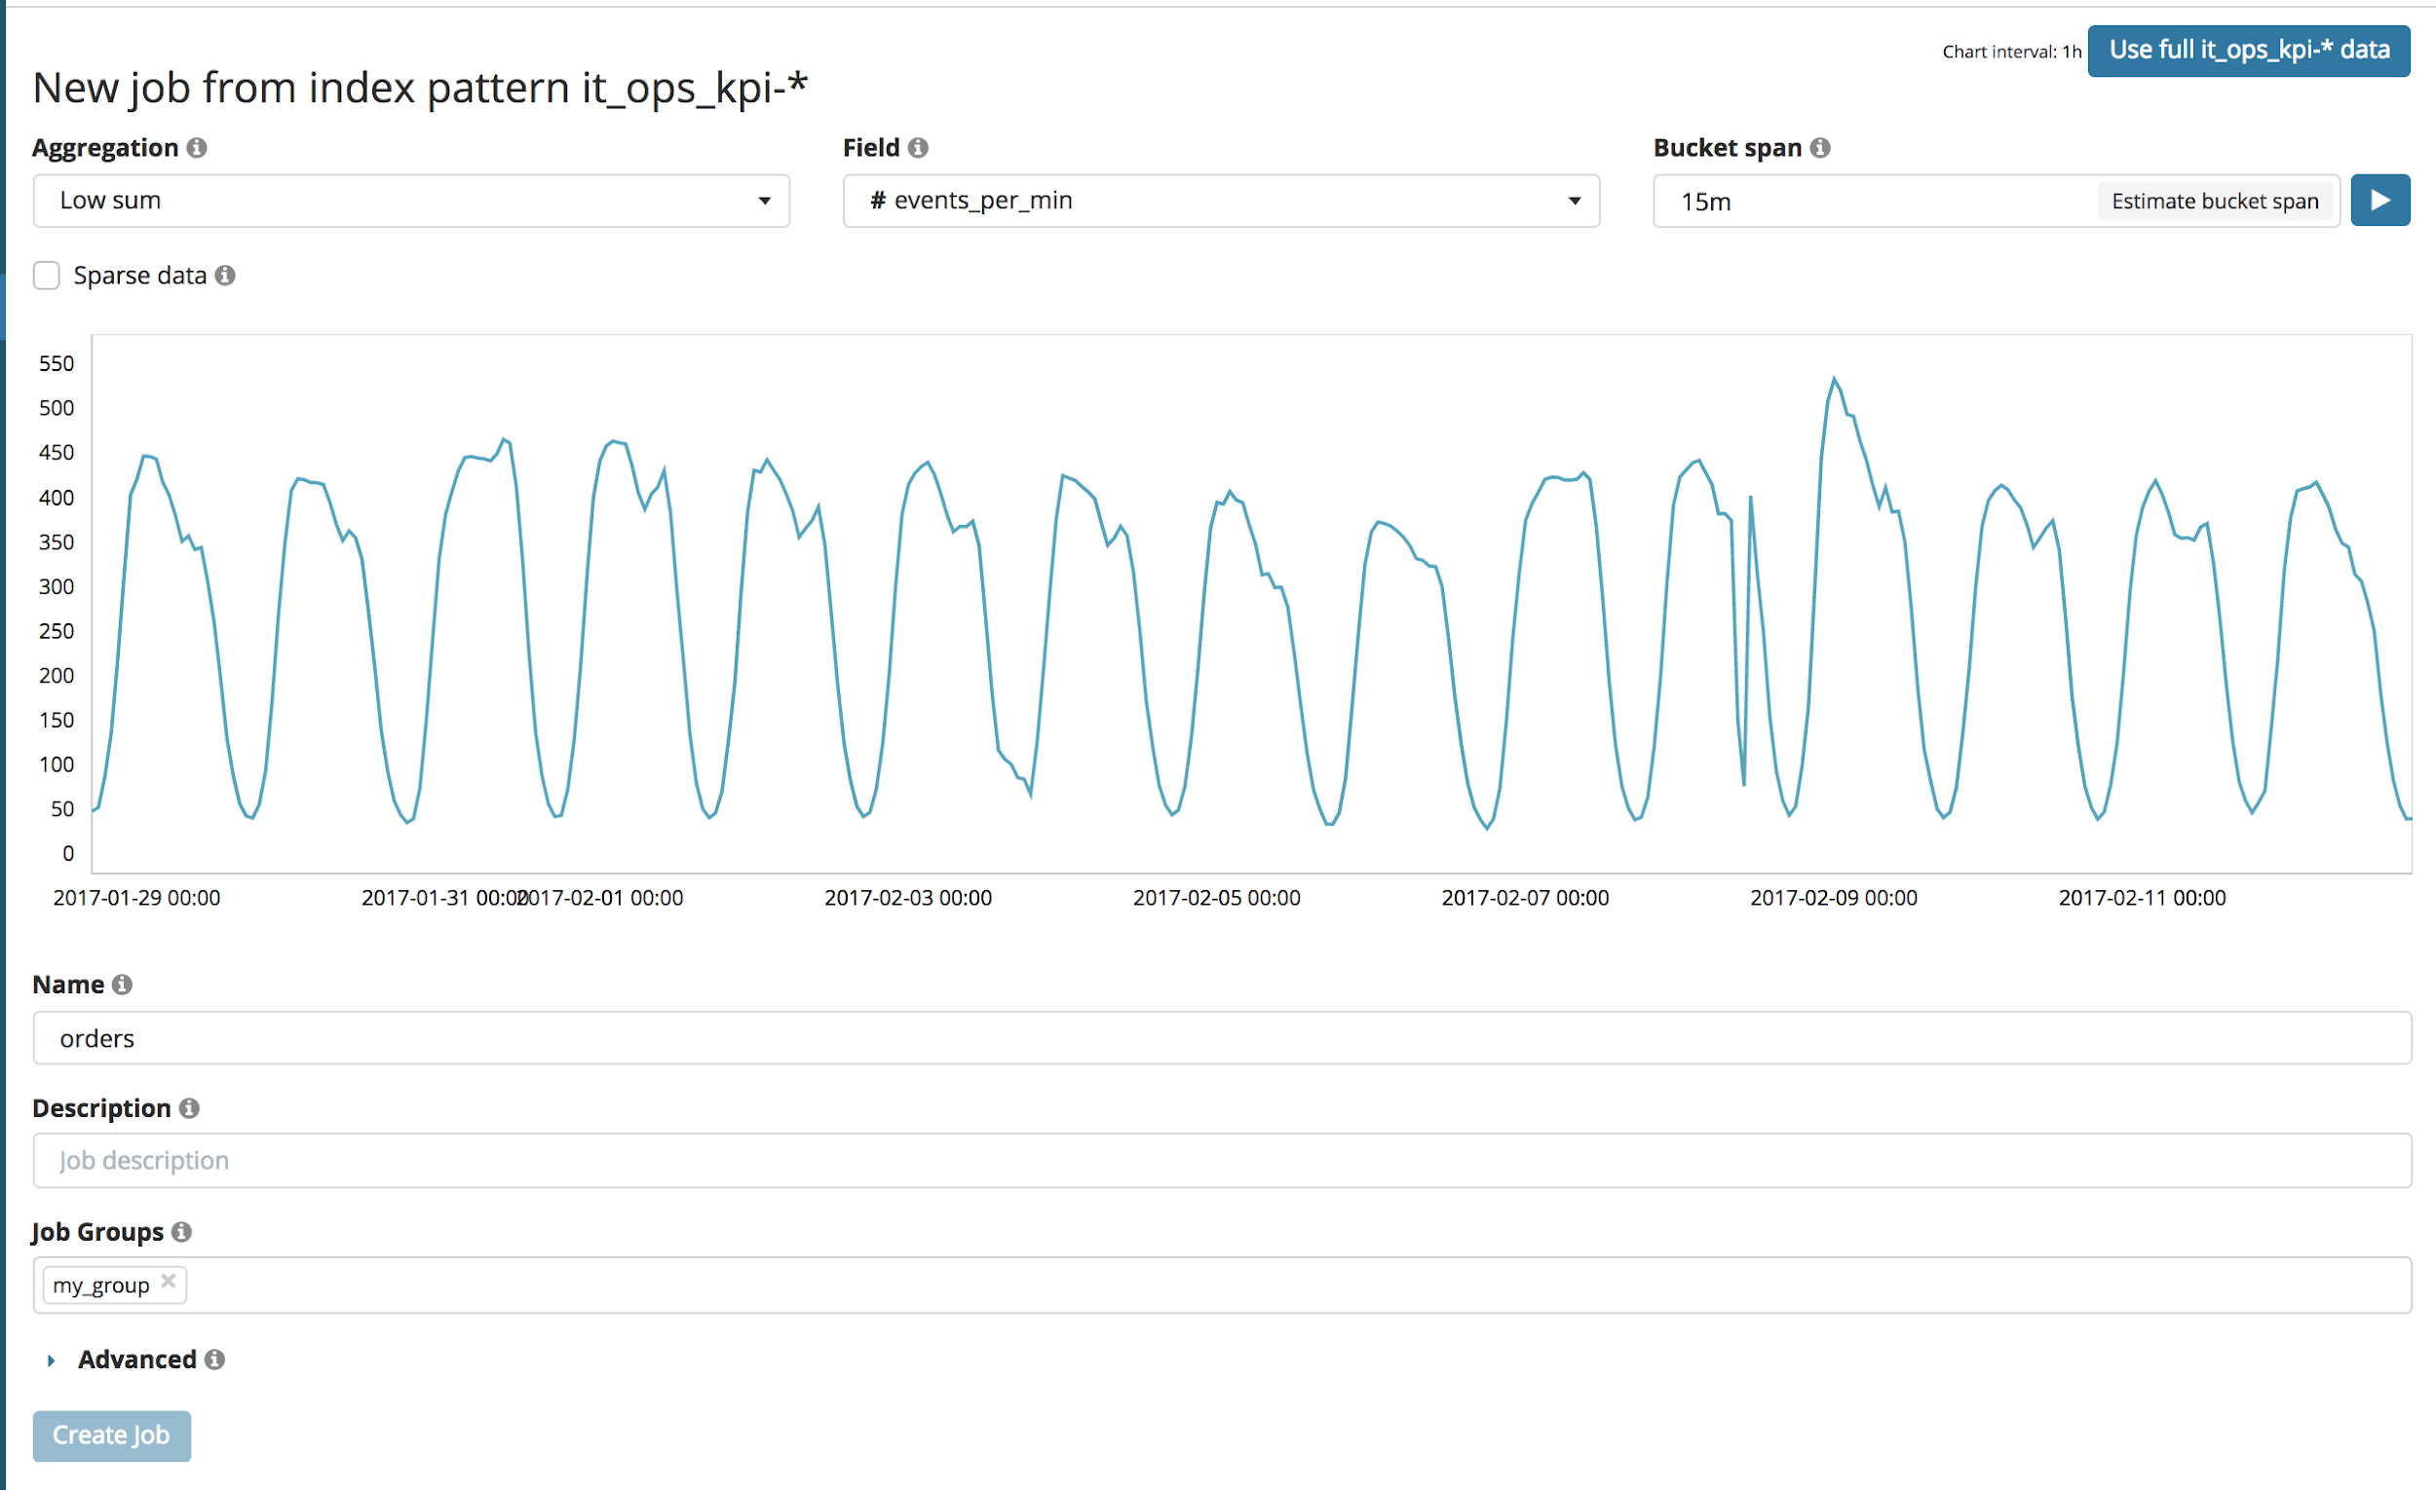

## View all jobs overlaid in the Explorer View

View all jobs in Group, see correlated anomalies

